ct

Creation of Task Controller Windows VM Using ARM template in Azure (PowerShell)

**REVISION INFORMATION**

|  |  |  |  |
| --- | --- | --- | --- |
| VERSION | DATE | DESCRIPTION | author |
| 1.0.1 | 03/02/2022 | INITIAL VERSION | 2087569 |
|  |  |  |  |
|  |  |  |  |
|  |  |  |  |

**About the Document**

**Purpose**

The purpose of this document is to elaborate the steps involved in SQL Server Virtual Machin Creation in Azure using ARM template with the help of PowerShell script.

**Intended Audience**

This document in intended to serve Cognizant Healthcare Product Consulting implementation team. Distribution of this document outside Cognizant employees and direct contractor is prohibited.

Table of Contents

Overview 4

Pre-requisite 4

Azure account with active subscription 4

Az PowerShell module installed on machine. 4

Azure Key Vaults to store VM Passwords and other sensitive data 4

ARM template & parameters template for VM creation 6

Execution 7

Reference 8

# Overview

This document is consisting of ARM templates for SQL Server Virtual Machine creation and PowerShell script to for automation with all steps to be followed to achieve the same.

# Pre-requisite

Expand below subsections for more details.

## Azure account with active subscription

Example: Subscription ID : 279e9b6e-b505-4d37-8bae-1544f55149da



## Az PowerShell module installed on machine.

1. This step needs to be followed only at first time If Az Module has been installed already, please skip this.
2. Open PowerShell and run this below command to install Az Module
3. Install-Module -Name Az -Scope CurrentUser -Repository PSGallery -Force
4. Hit Enter button while installing if it is asks for NuGet Provider to be installed.

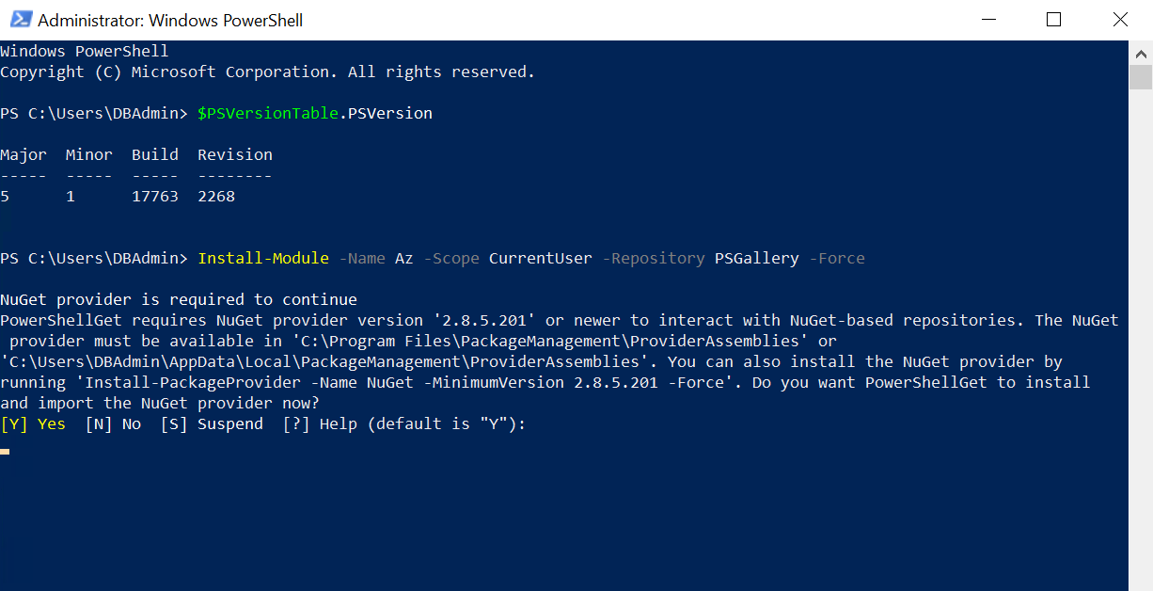

## Azure Key Vaults to store VM Passwords and other sensitive data

* 1. This is the service available in Azure portal to store sensitive data.
  2. Navigate to **Key Vaults** in Azure Portal and click on **Create**

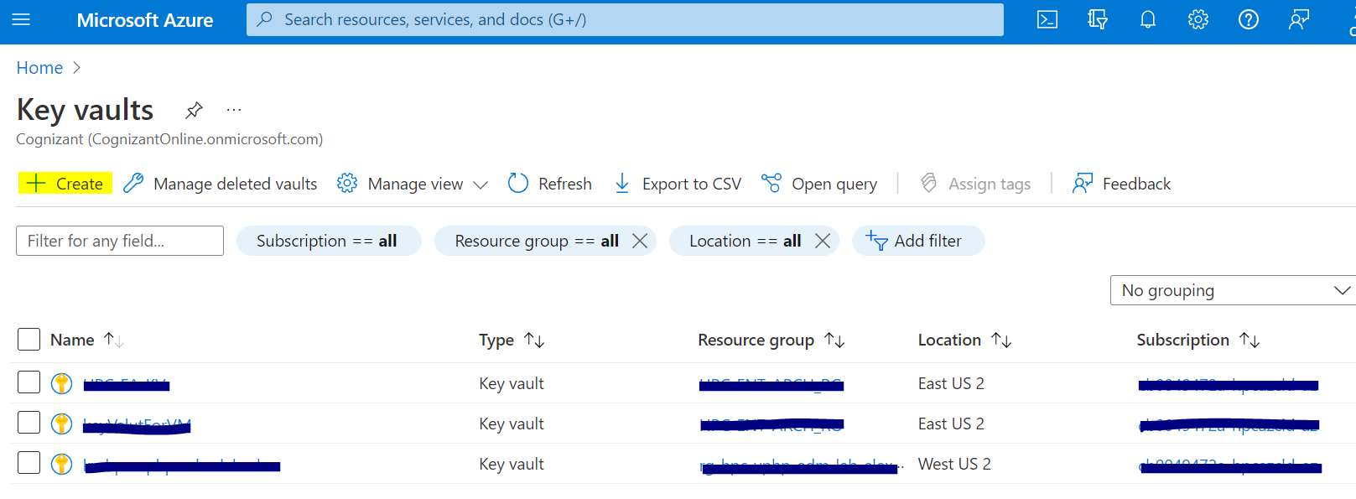

* 1. Fill the required details to create Vault and make sure that you select the **Azure Resource Manager for template deployment**

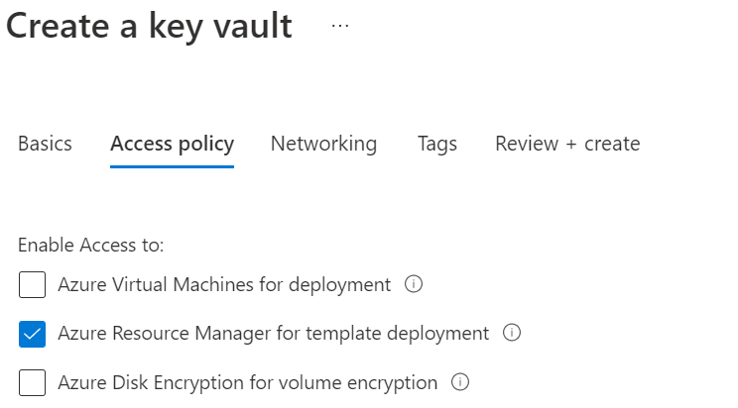

* 1. Once the Vault is created open it and Navigate to **Secrets** and click on **Generate**

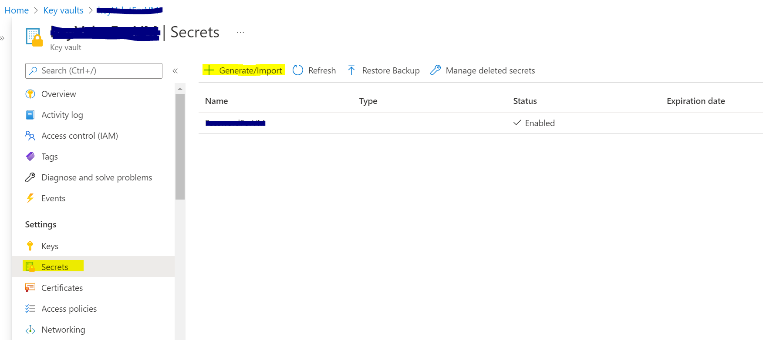

Provide the **Name** (PasswordForVirtualMachine) and **Value** (Password) to add secret.

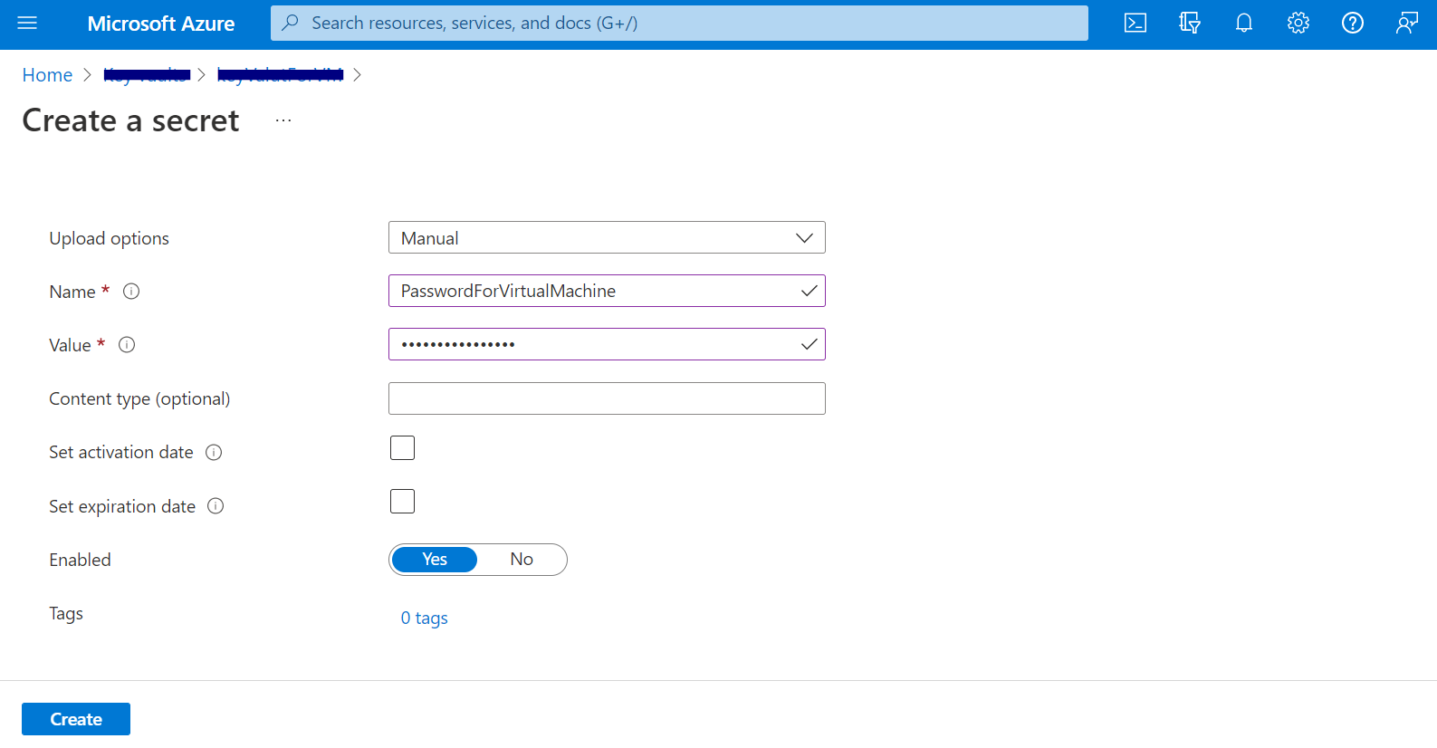

* 1. Provide the **Name** (PasswordForVirtualMachine) and **Value** (Password) to add secret.



* 1. Once the secret has been added, Get the resource id of vault created in PowerShell using below command.
  2. Get-AzKeyVault <VaultName>
  3. Make note of resource id and secret name.

## ARM template & parameters template for VM creation

1. Below are the Templates for VM creation.
2. 
3. Download both templates and store it in new folder.
4. Open **FinalsqlServerVM.parameters.json** and edit the parameters according to your requirements.
5. And provide the keyVault reference in the same file as shown in below images.

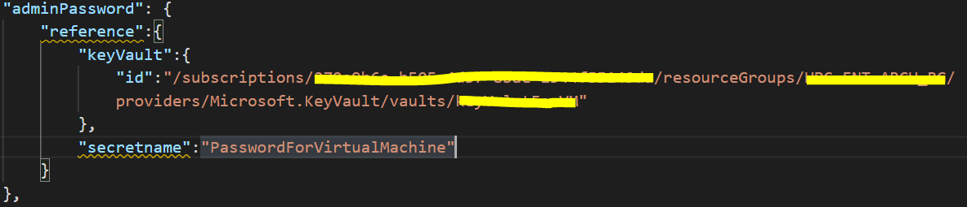

1. In this file we have only one password that is for VM admin.

We are done with all the prerequisites.

# Execution

1. Open Windows PowerShell ISE and open this below file.



1. Please update the script file by replacing the <PATH>, <SUBSCRIPTIONID> , and <RESOURCE-GROUP-NAME> with actual values and save it as **VMCreationScript.ps1** instead of **VMCreationScript.txt**
2. Run the script to deploy SQL Server and wait for the deployment to finish.
3. Below is the sample output of the deployment.

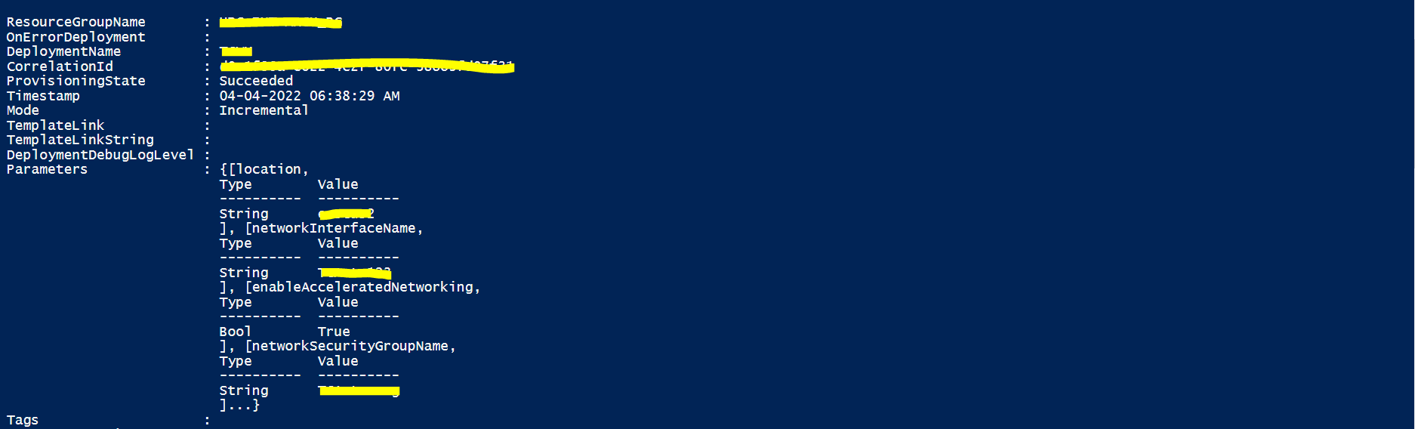

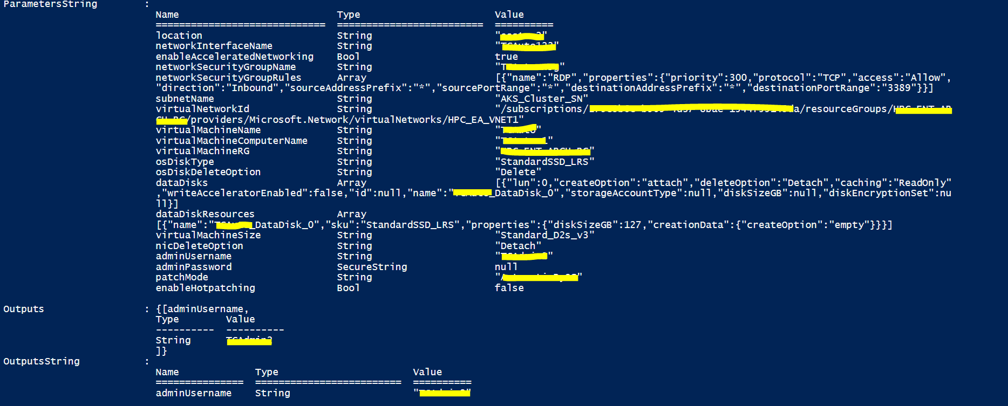

# Reference

* [ARM Templates Documentation](https://docs.microsoft.com/en-us/azure/azure-resource-manager/templates/)
* [Az Module PowerShell](https://docs.microsoft.com/en-us/powershell/azure/install-az-ps?view=azps-7.3.2)
* [Azure Key Vault](https://docs.microsoft.com/en-us/azure/key-vault/general/basic-concepts)
* [Virtual Machines in Azure](https://docs.microsoft.com/en-us/azure/virtual-machines/)